Energy Medicine To The Rescue
Marcus Freudenmann 07-16-2013 45 Comments
At the Arcadia Clinic in Germany we are very excited to observe massive changes in a patients energy when they are treated with PEMF. Most patient describe the treatment which is often combined with high dose of Oxygen IV as the energy boost of the day.
Since the clinic has incorporated this treatment their results have massively improved. The energy level of a patient is much higher, the absorption of nutrients manifold increased, detoxification is enhanced and the response to hyperthermia with anti cancer remedies is much more direct.
Patients describe massive improvement in their emotional state as well as they are recharged. Some of the more advanced patients have experienced lifting of brain-fog and others describe an increase of clarity and direction. When you see the video which is taken directly before and after the PEMF treatment you can understand why.
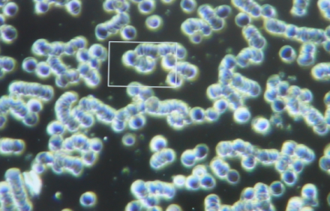 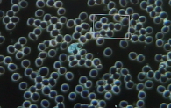 By the way….
We have tested several patients with extremely bad blood values before and after the PEMF treatment as well as the next morning to see how long the effects hold. The results are amazing. Even in patients with severe gut or joint inflammations and high acidity the effects seem to hold at least for a couple of days.
The most powerful observation of all is the increased activity, size and movement of the white blood cells. They seem to double in size and move like well trained soldiers defending their host.
I will report in length about our findings in energy medicine and especially PEMF. This treatment has surpassed all our expectations and literally blew our minds when we saw the effects on immune cells directly under the dark-field microscope.
Visualize this treatment as a life-energy-boost that mobilizes all your cells to the max capacity.
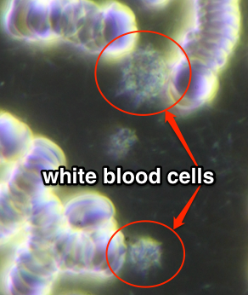In the image to the left you see 2 white blood cells circled in red in an anaerobic and inflamed body. They are about the size of a red blood cell. Highly compressed and completely immobile. There was hardly any movement visible inside the cell.
While observing the blood on screen we realised that all cells, red and white fell apart within 3 to 8 min. The outer membrane disintegrated and the cell collapsed in a very short time. This lack of energy was also apparent in the patient. No energy at all. She complained about fatigue and high levels of stress.
If you see these two compressed cells representing your complete immune system then there is little hope for any healing or defense. These cells can barely survive on their own, despite performing their job.
It is also very evident that no chemical substance (vitamin C, DCA, B17, or Artemisin) which would normally be used for treatment of cancer would have any effect in such a state. Not even oxygen in high concentration could bind to these cells and mobilize the blood.
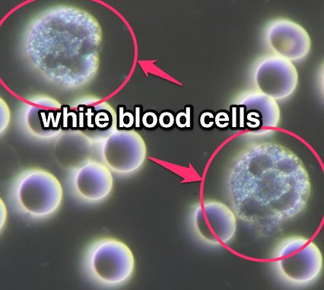In this picture you see the blood sample from the same patient just 20 minutes later after a 15 min PEMF treatment with the PMT-100.
(YES it’s the same patient and YES just 20 minutes later)
As you can see the white blood cell is about 3 times the size of the red blood cell and it moved very actively across the screen. Inside the cell the cytoplasm shimmered and moved vibrantly.
All cells held the membrane stability and mobility for around 45 min and tested again the next day in the morning the blood looked like this.
We will share with you in an upcoming post a detailed report about proper use of the device and the results we achieved with cancer patients.

